HW1 Face Detection

0616098 黃秉茂

Part 1 : Load and prepare your dataset

Import module I need (os for path and numpy for data)

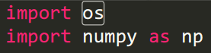

The function for checking if it is a pgm file

Chech the path is string or not, and check with extension(.pgm)

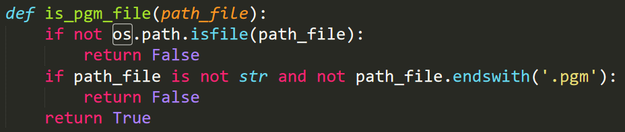

The function that can help me to get image to numpy array from pgm file

check if it is a pgm file 🡪 Read file 🡪 check magic number to ensure the format is correct 🡪 get image’s width and height 🡪 ensure the size of pixel value 🡪 get image content pixel value and store into a numpy array

magic number in pgm file is “P5P

first line in pgm file has magic number, second line is image’s width and height, and the rest is pixel values in grayscale

use “with open” to read file and use readline to get content of the line

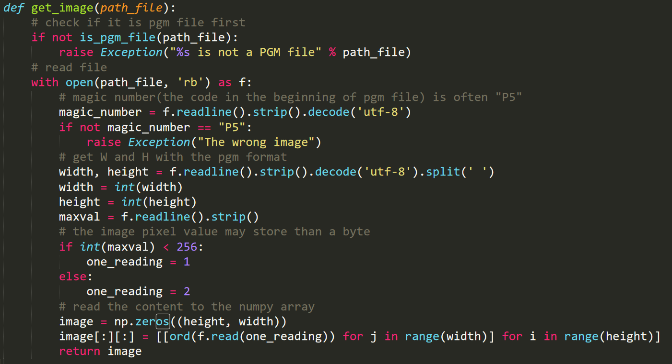

folder: “non-face” 🡪 label = 0, “face” 🡪 label = 1

travel each folder with os.listdir() and generate image path with “os.path.join(.)”

call the function I wrote above to get image to numpy array from pgm file

the image and label are appended into the list

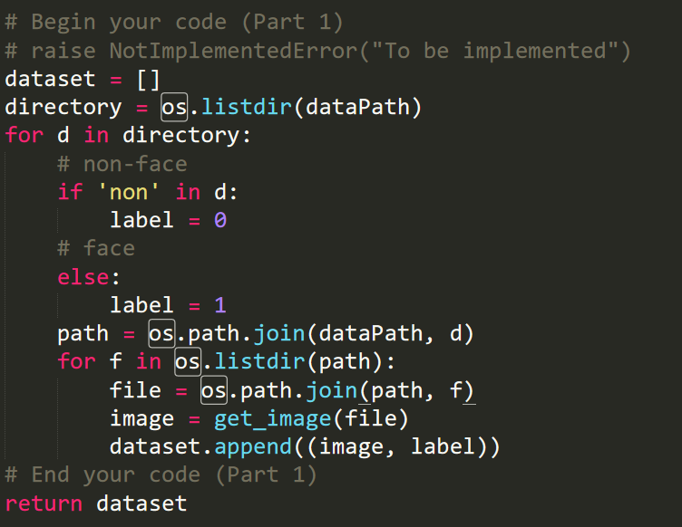

Appear the follow picture means successed (face, non-face)

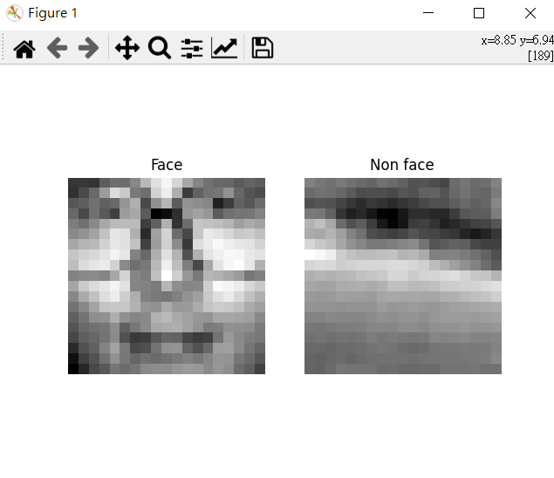

Part 2: Implement Adaboost algorithm

Initialize

create weak classifier with each feature

use iis to get the result the classifier predict

use absolute value to be error evaluation and multiply the L1-norm by weights

choose the minimum error as the best error and choose weak classifier according to the error

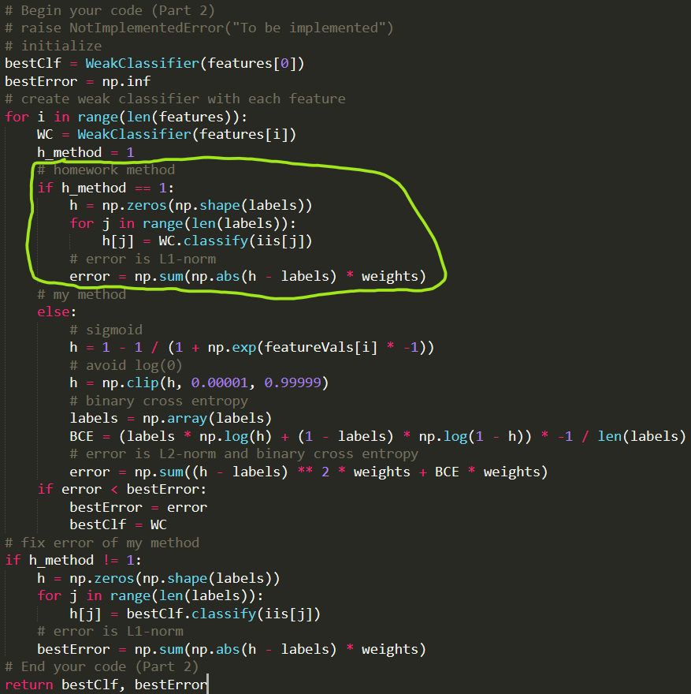

Part 3: Additional experiments

T = 1

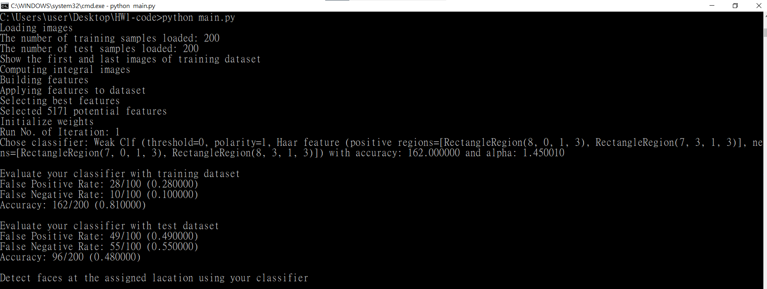

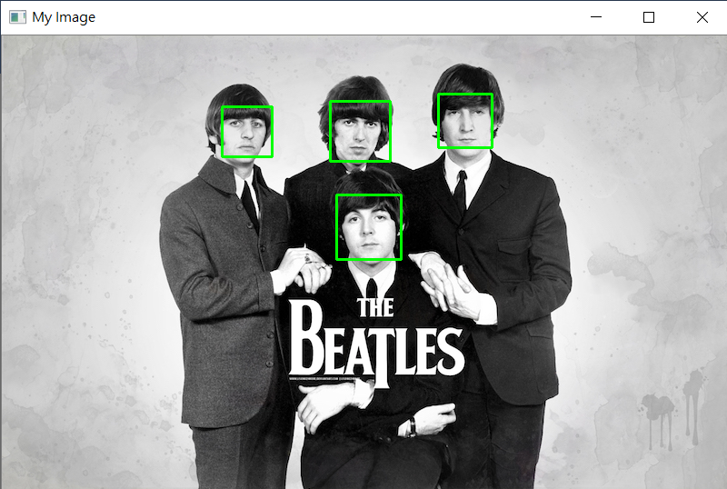

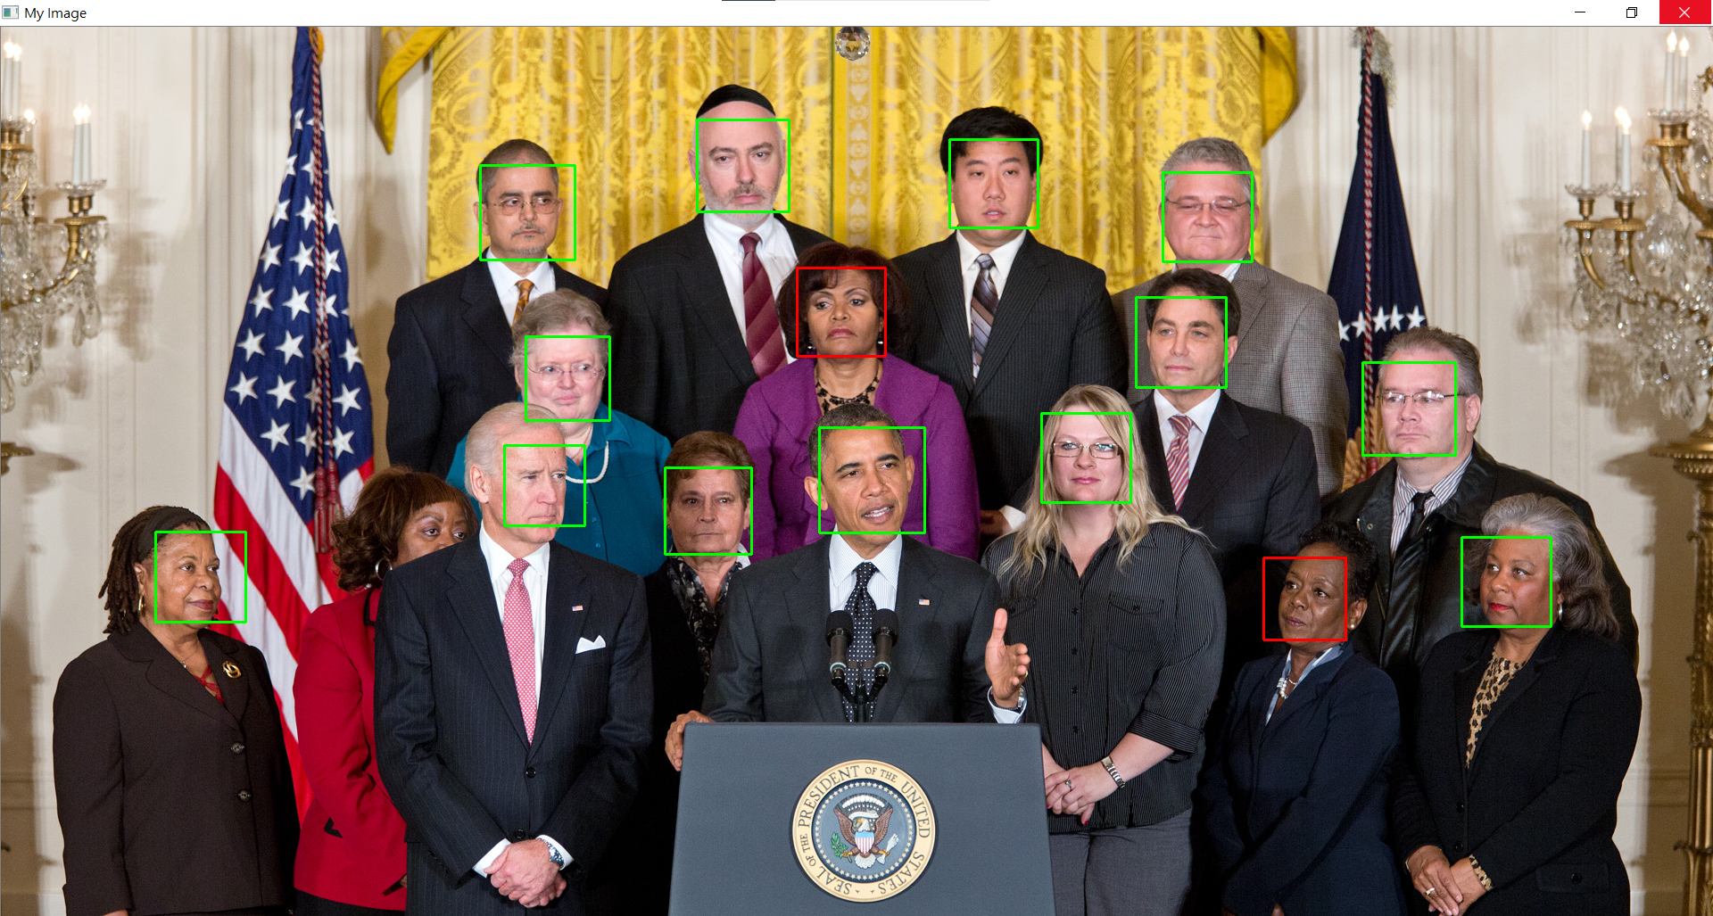

T = 2

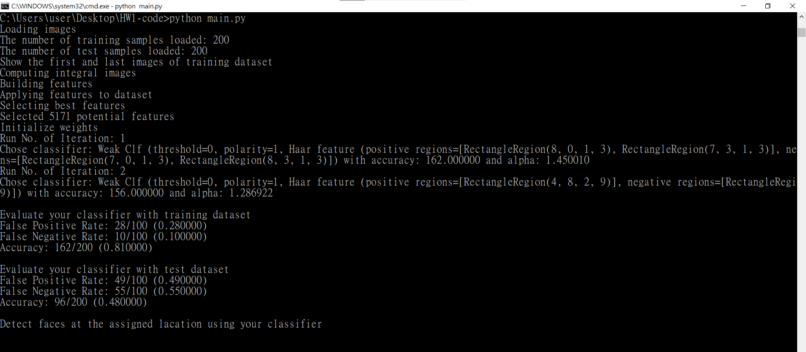

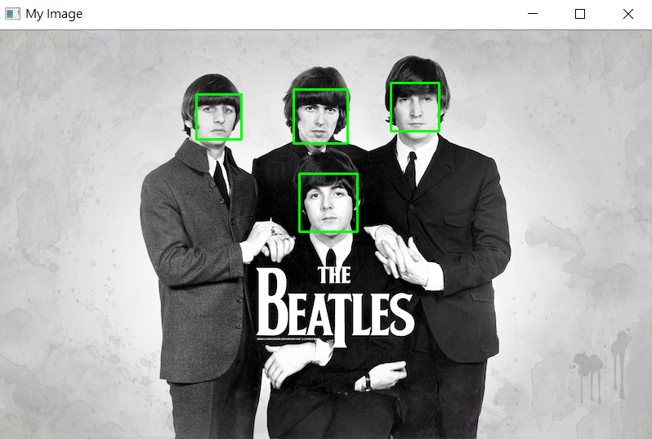

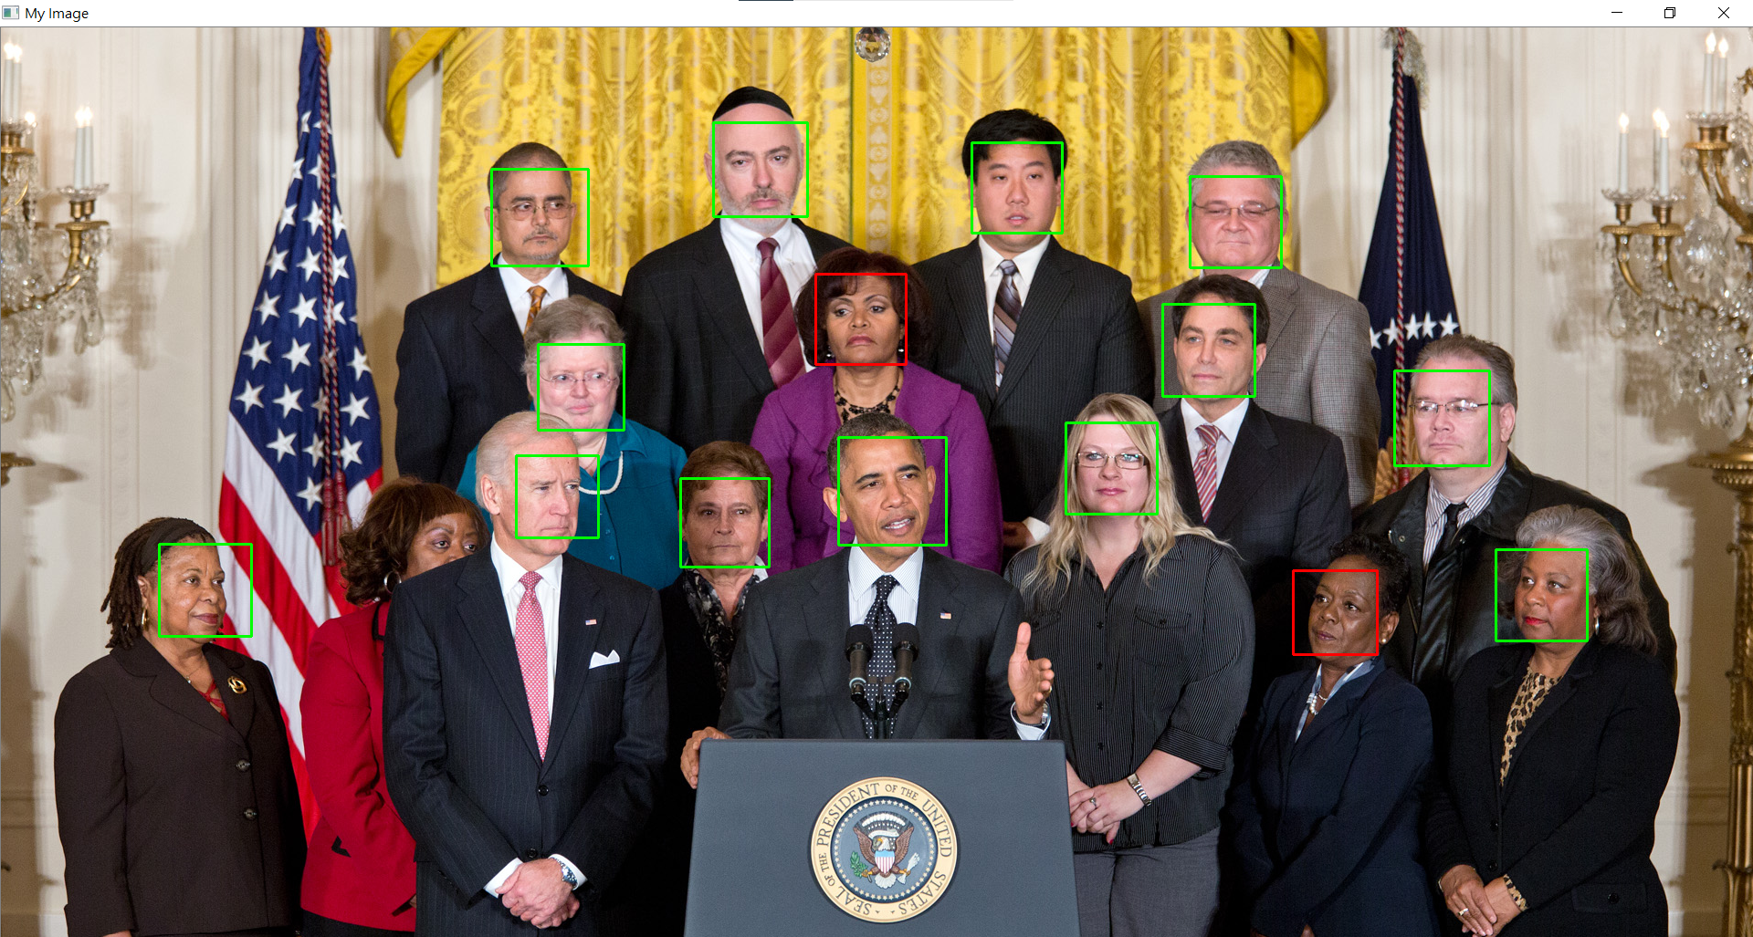

T = 3

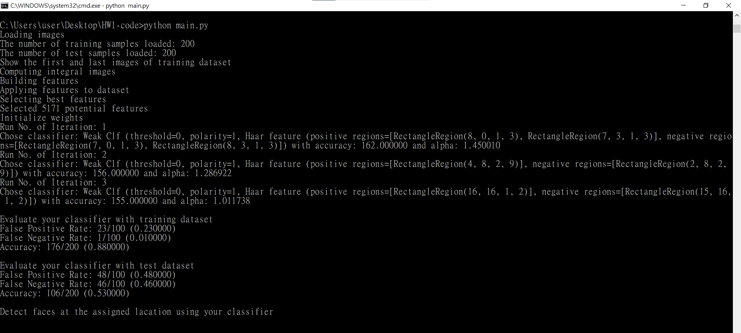

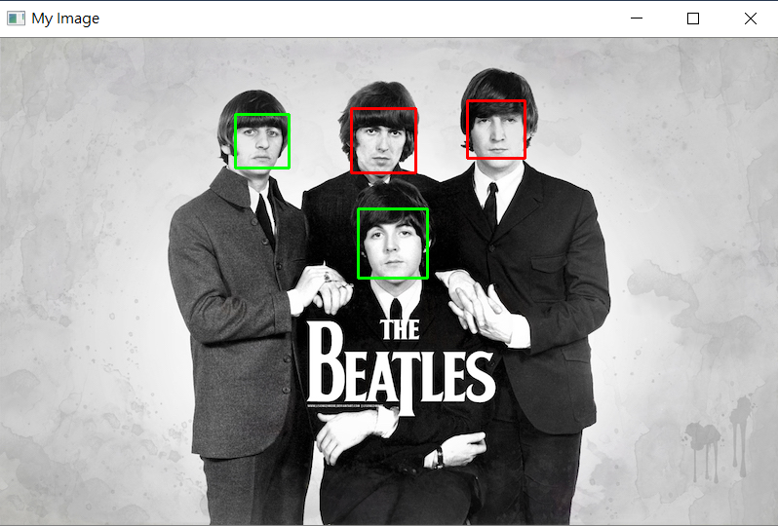

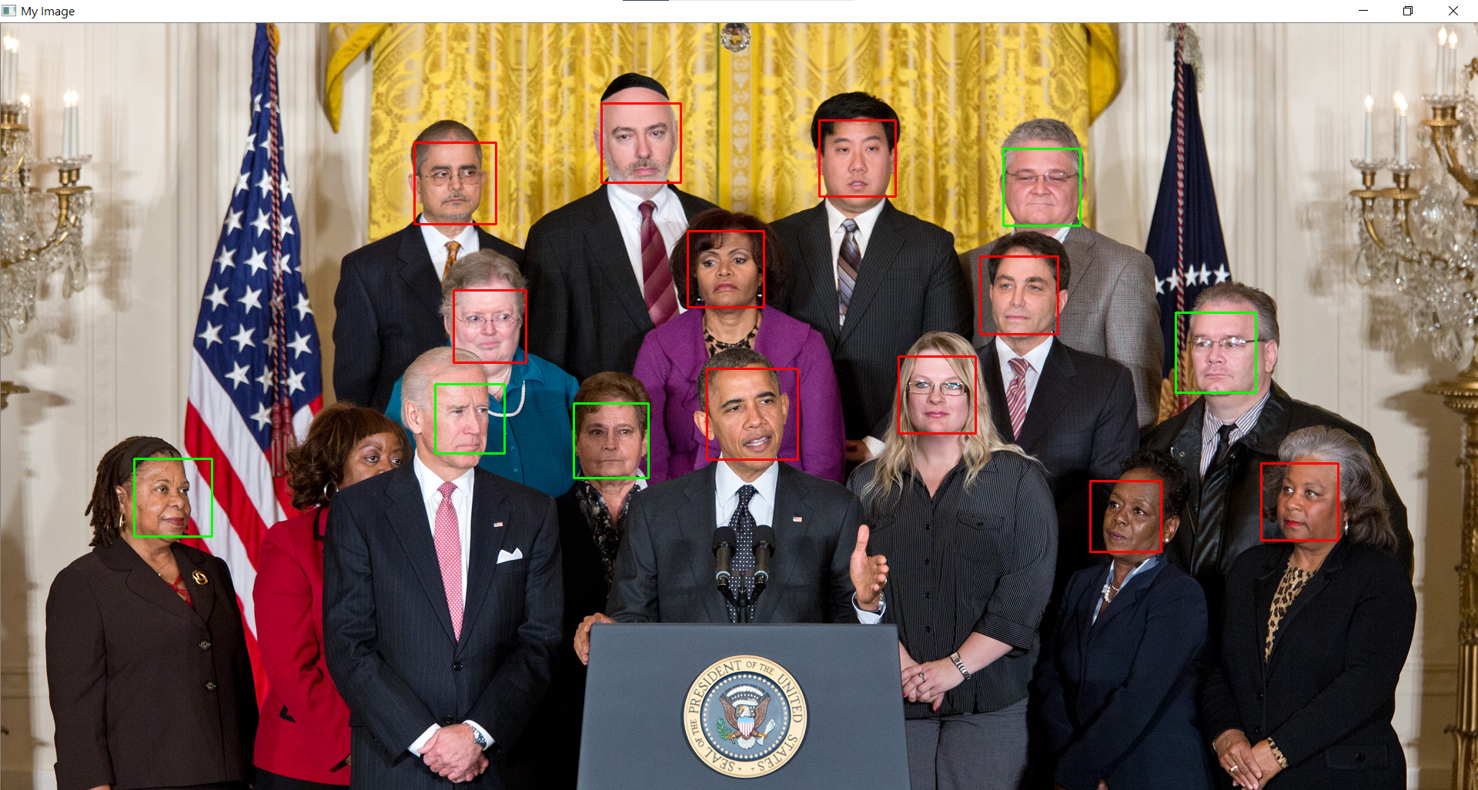

T = 4

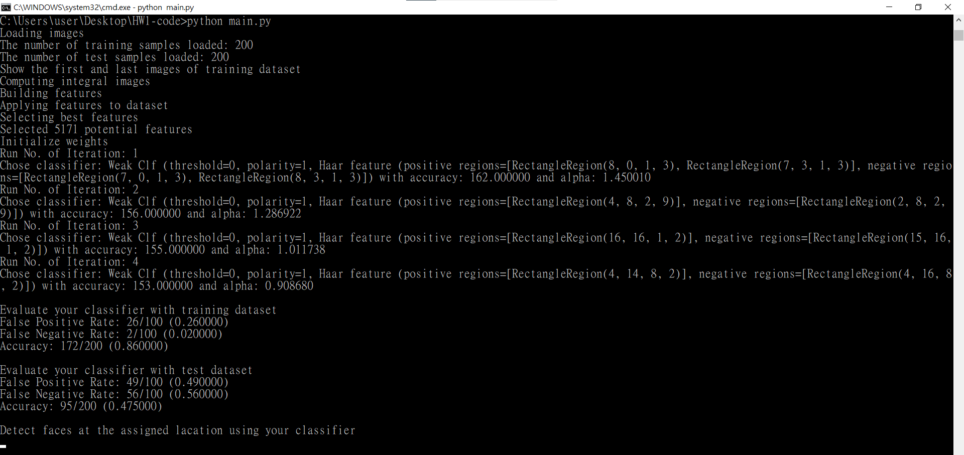

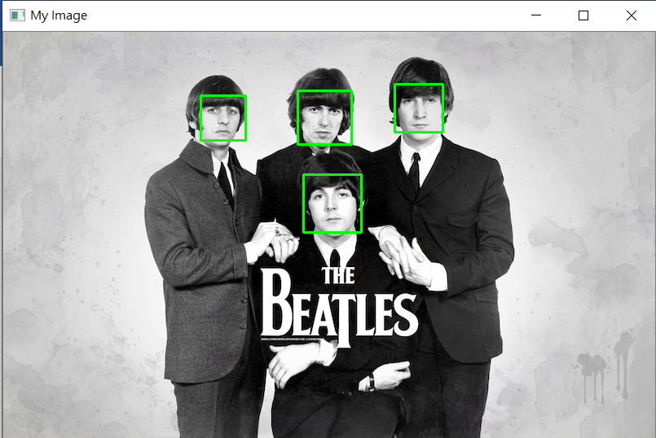

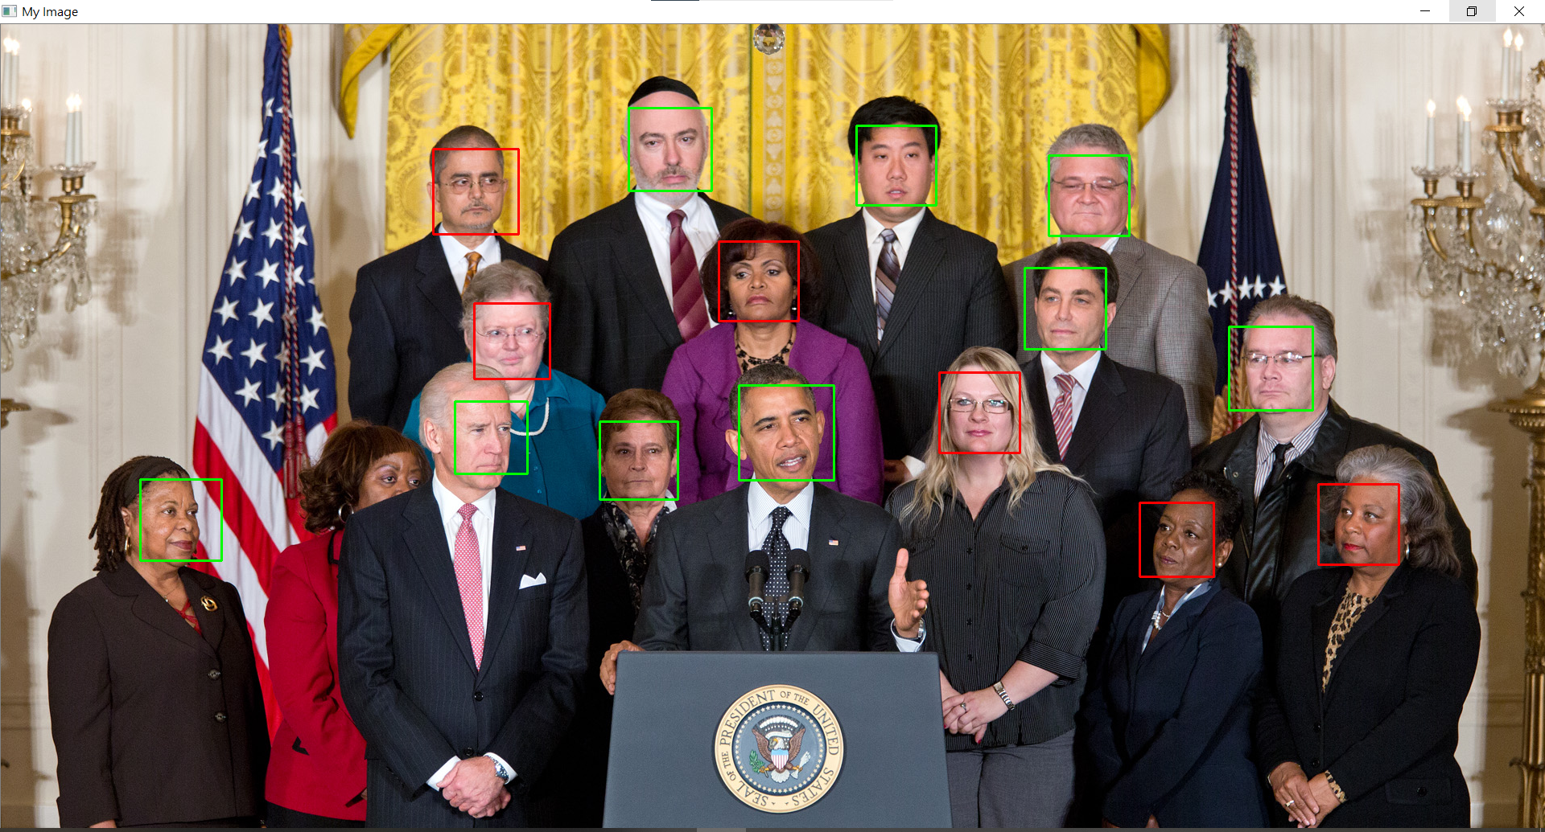

T = 5

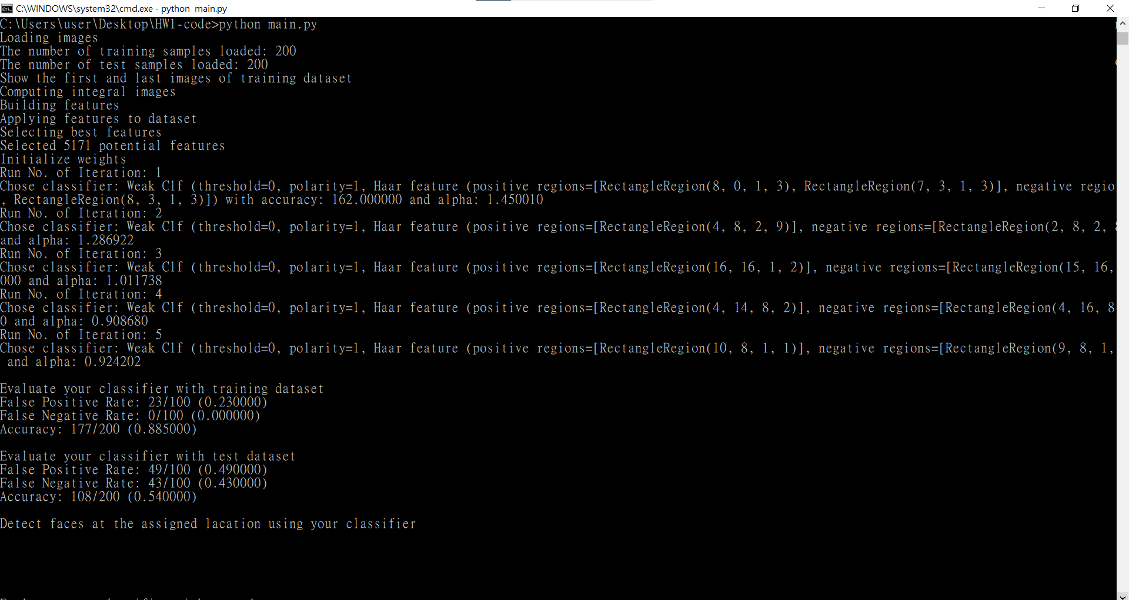

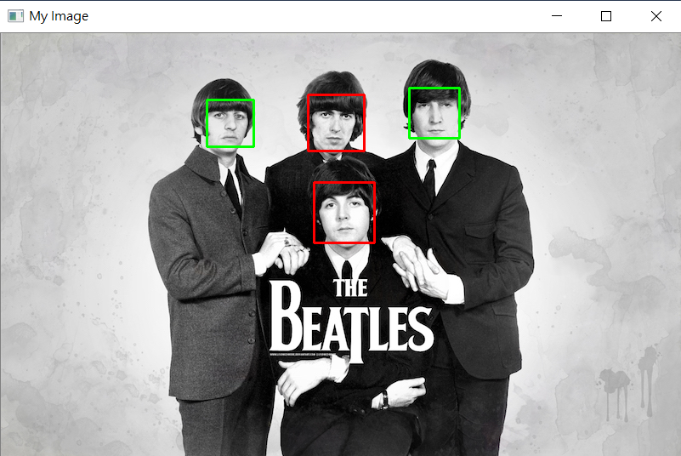

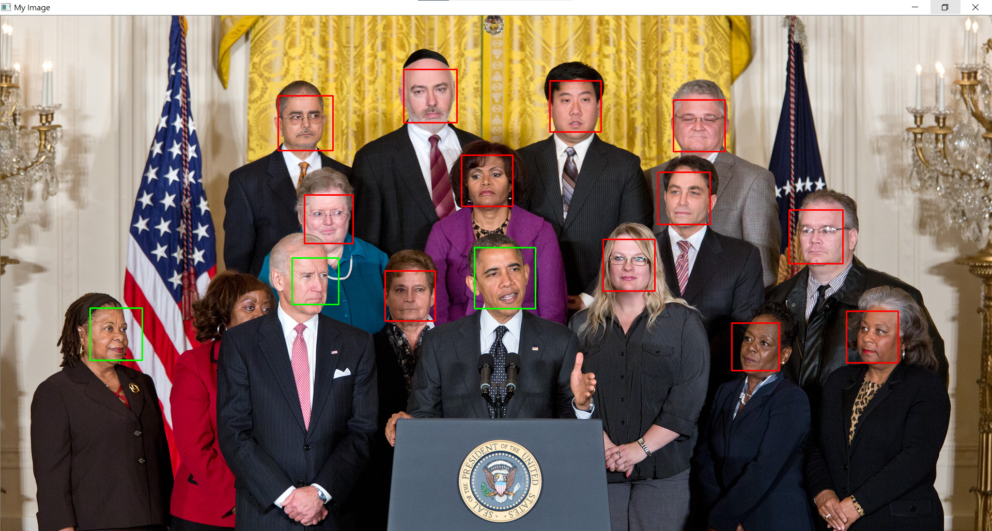

T = 6

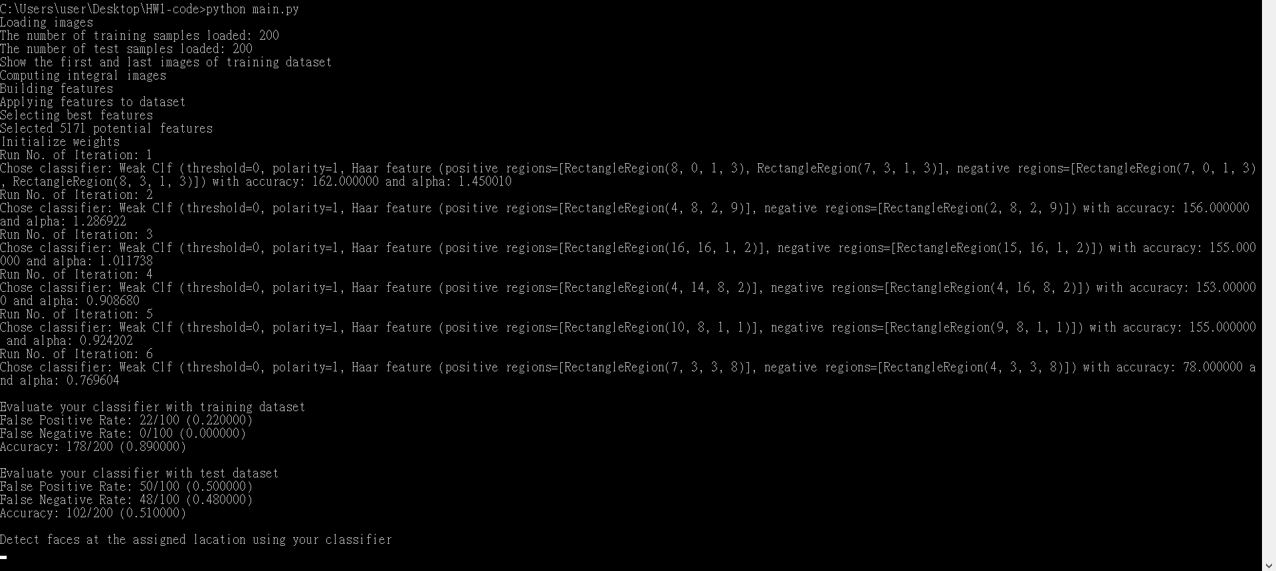

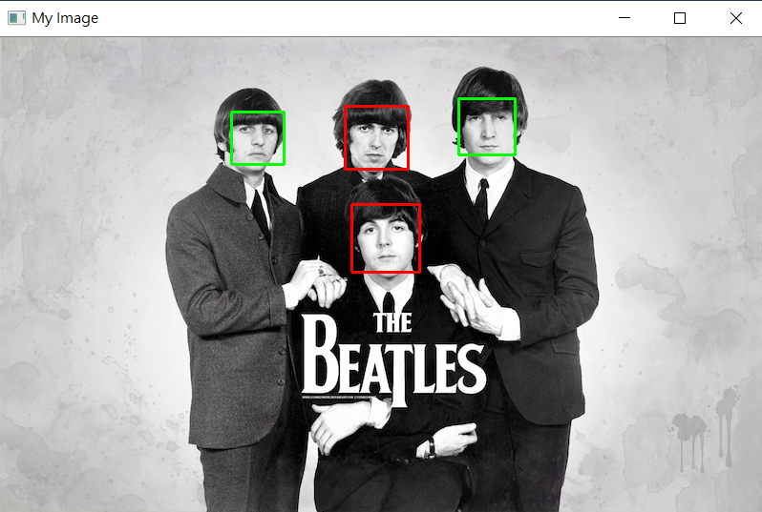

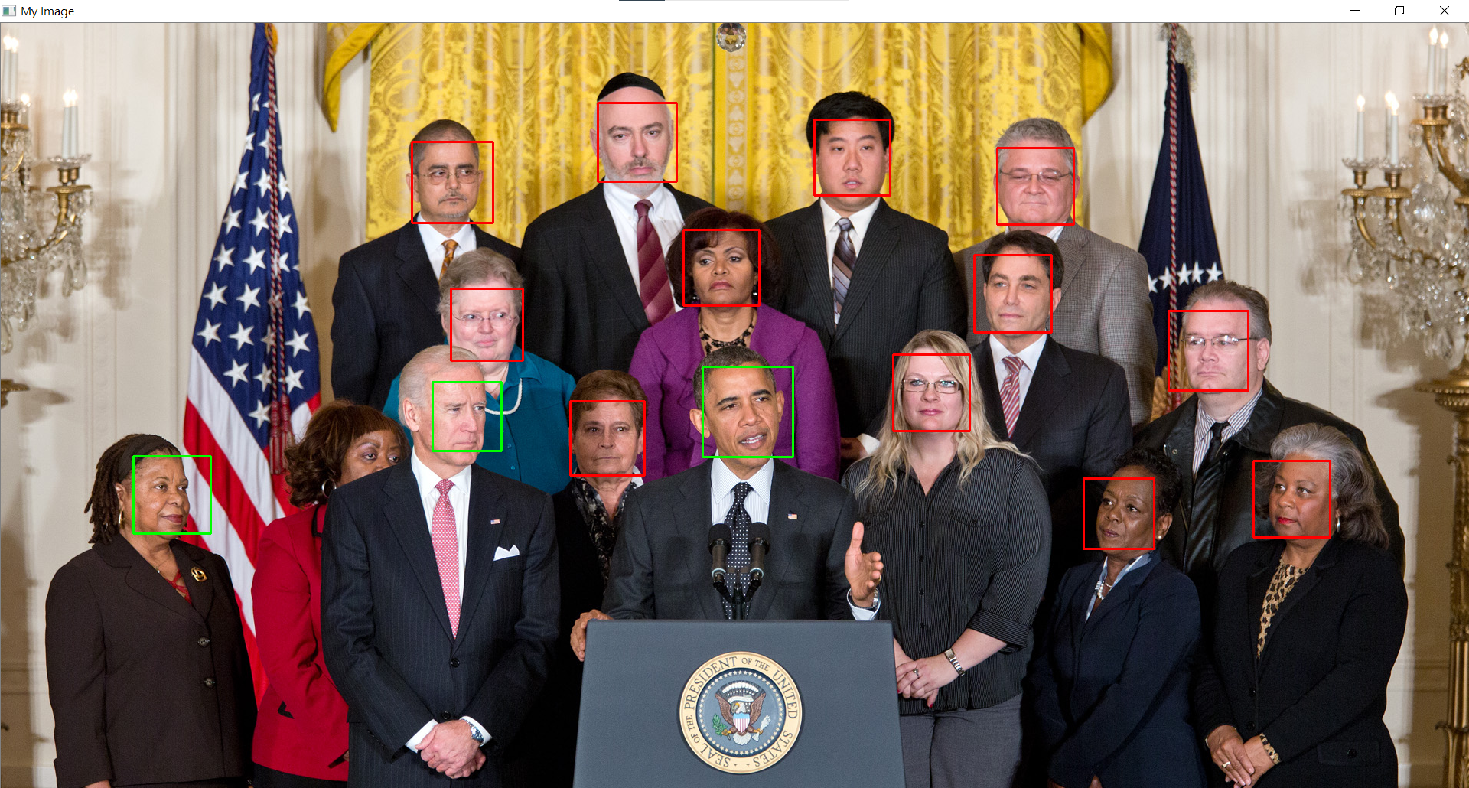

T = 7

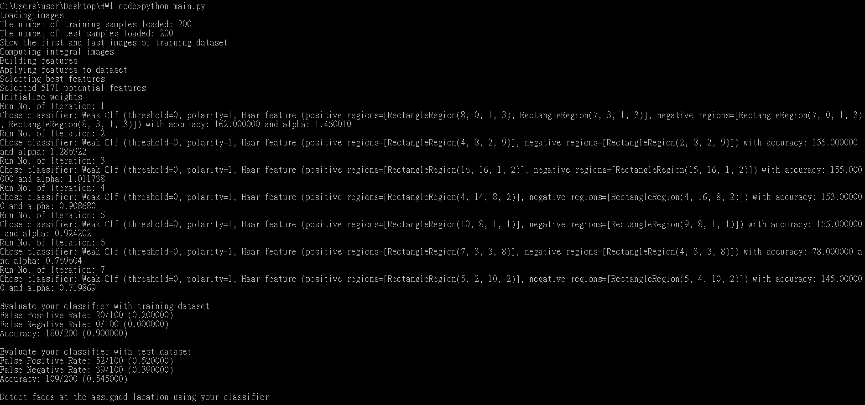

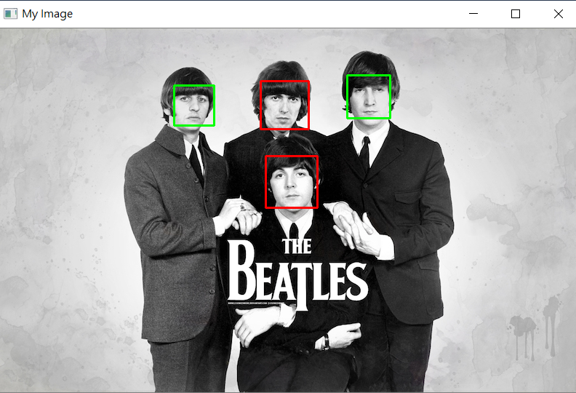

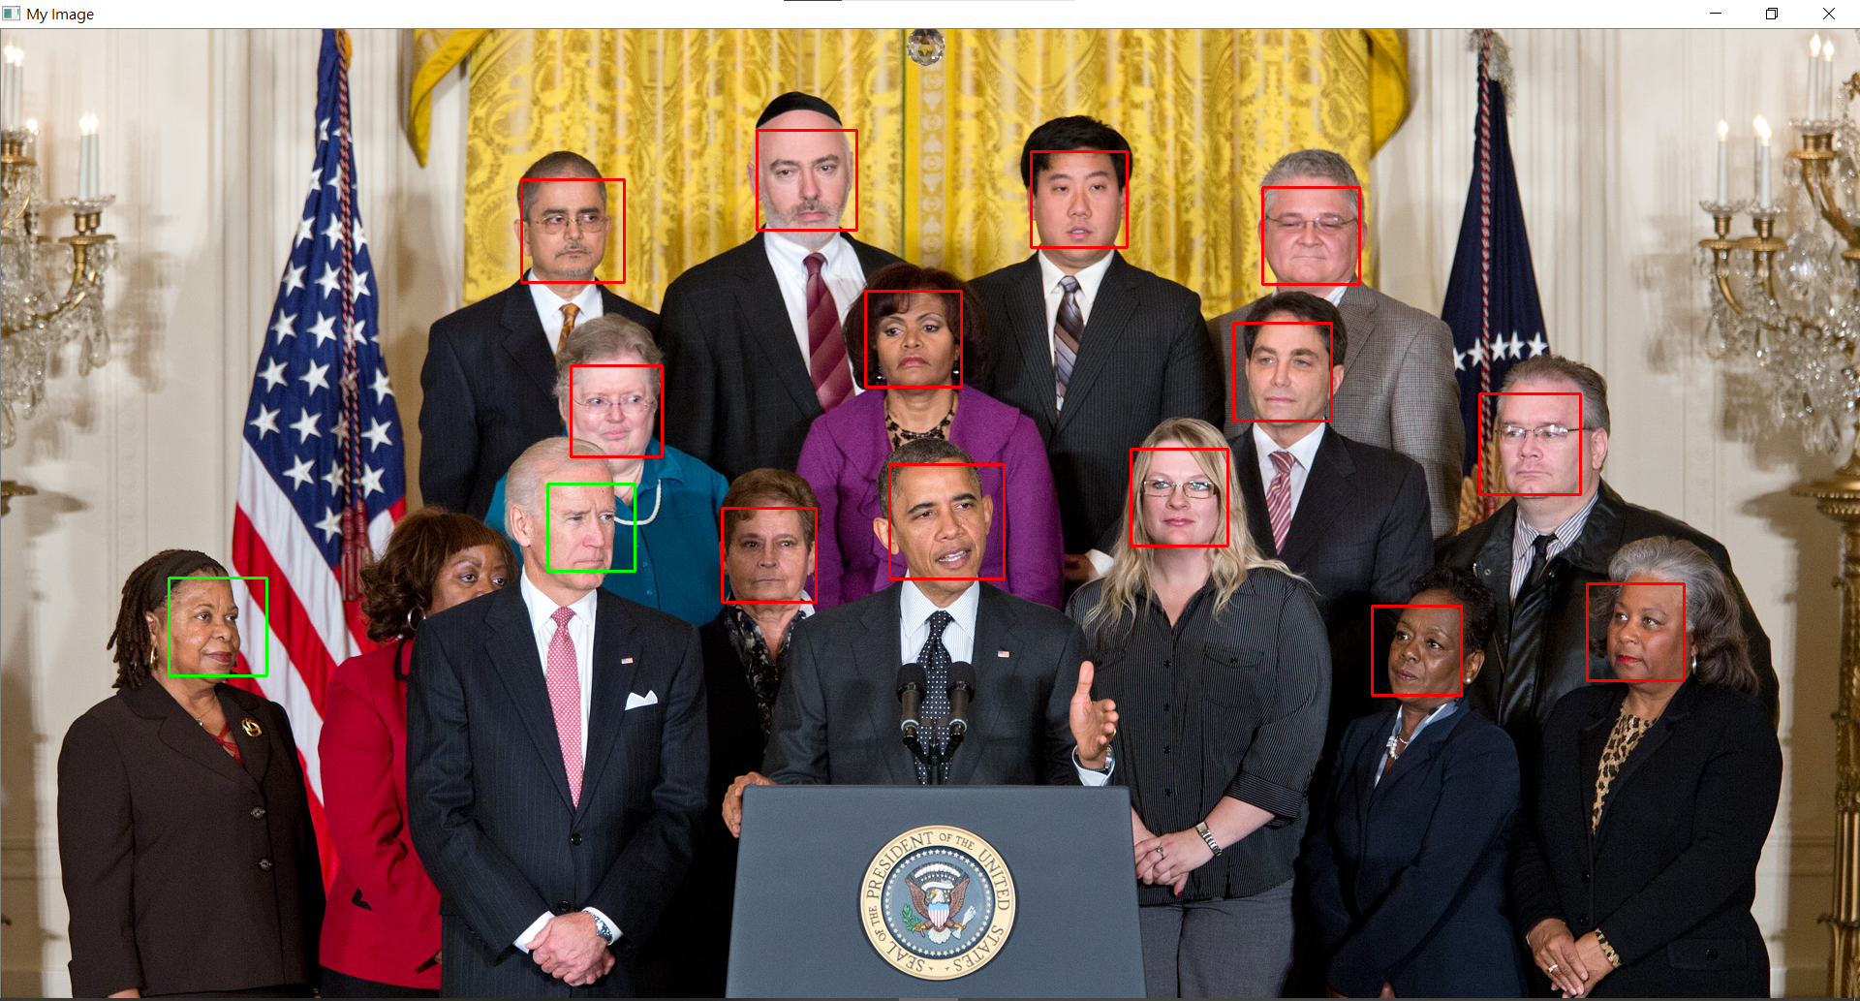

T = 8

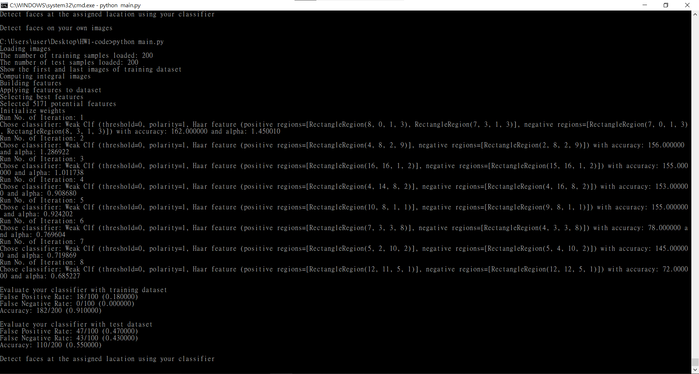

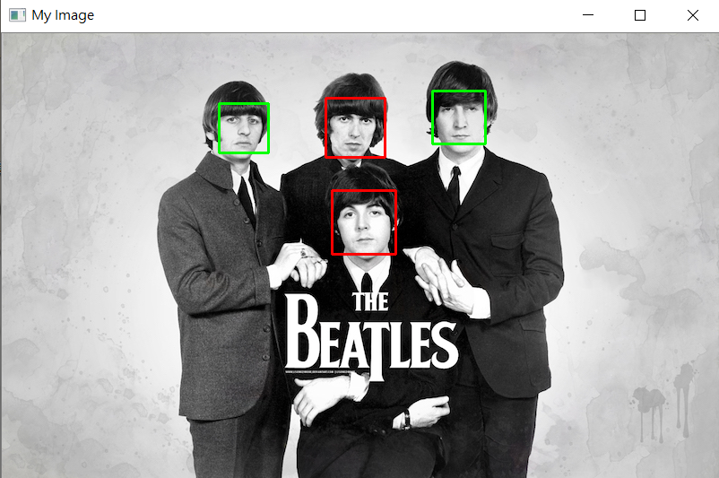

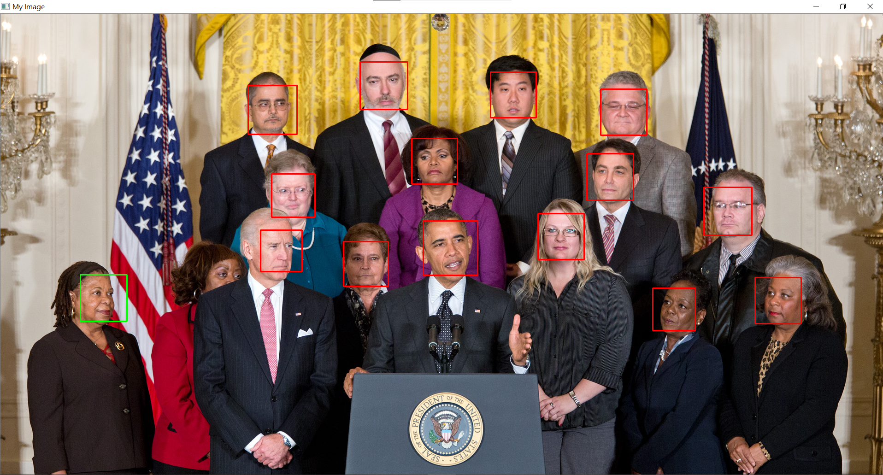

T = 9

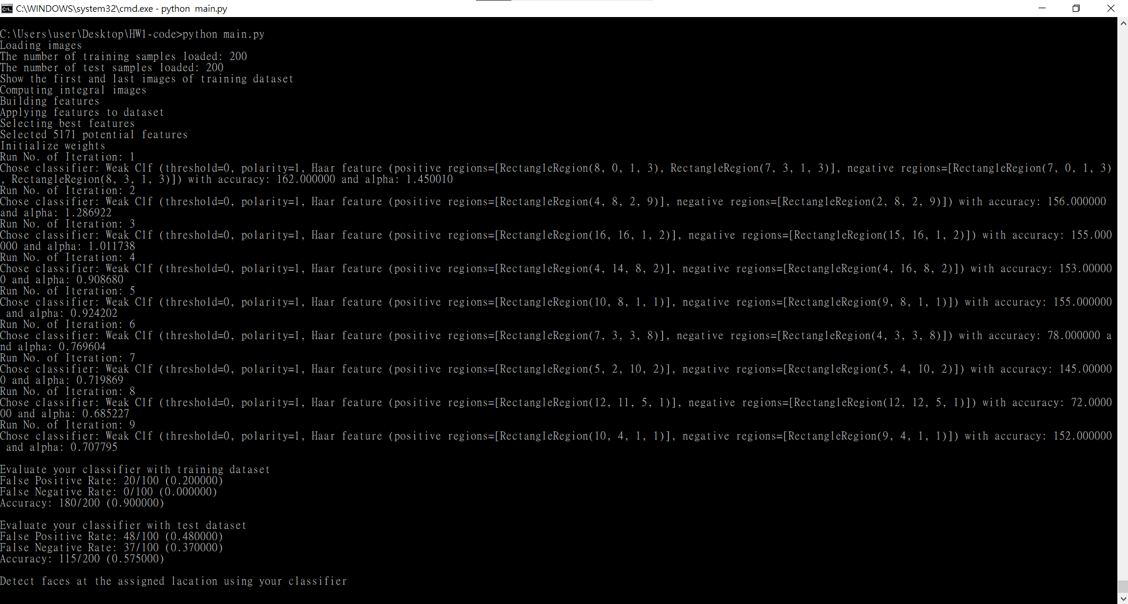

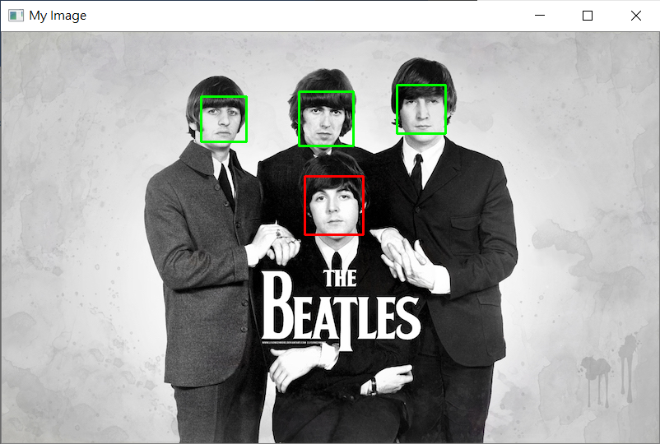

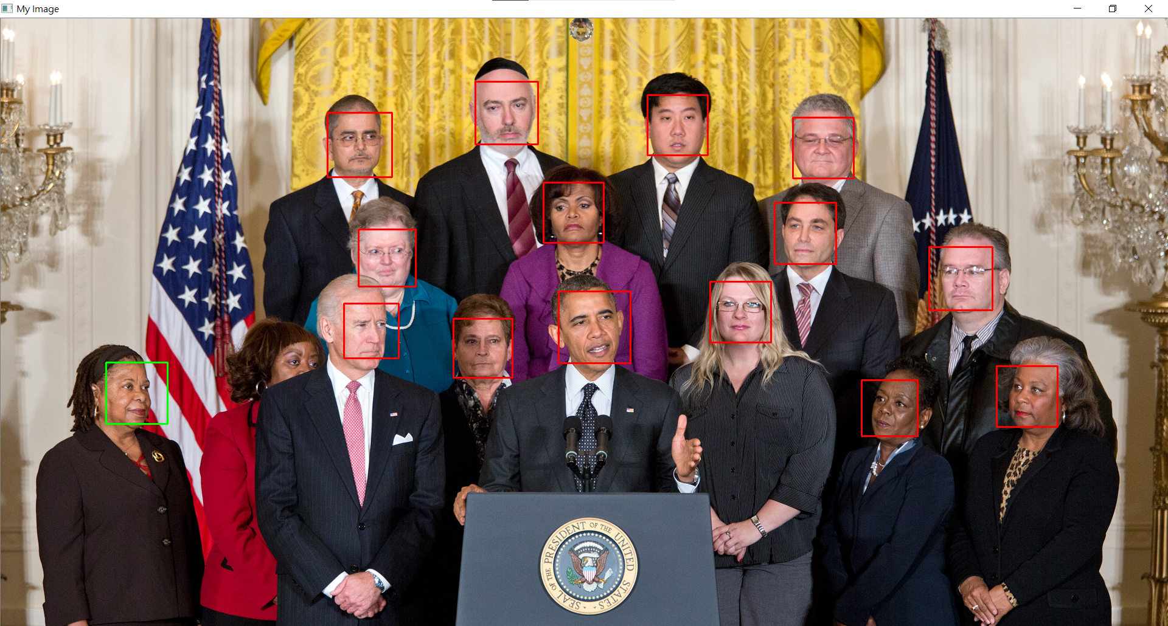

T = 10

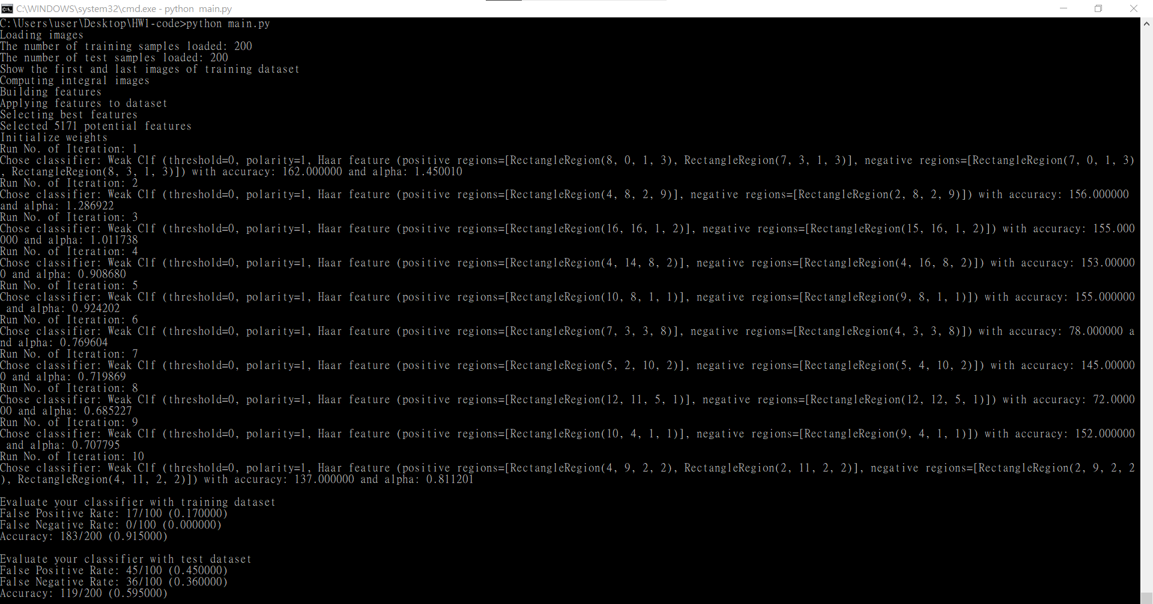

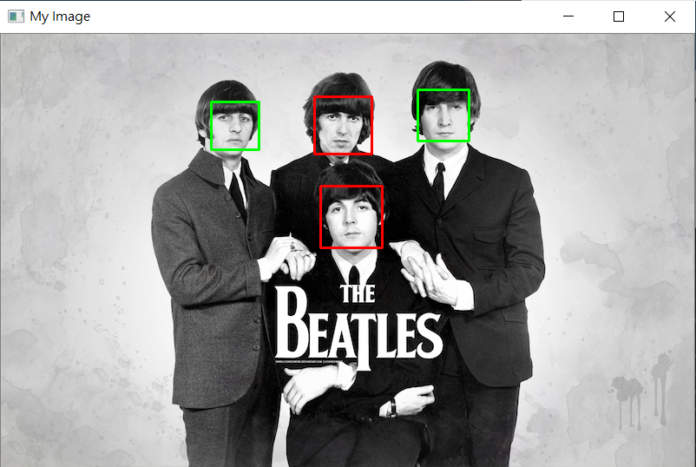

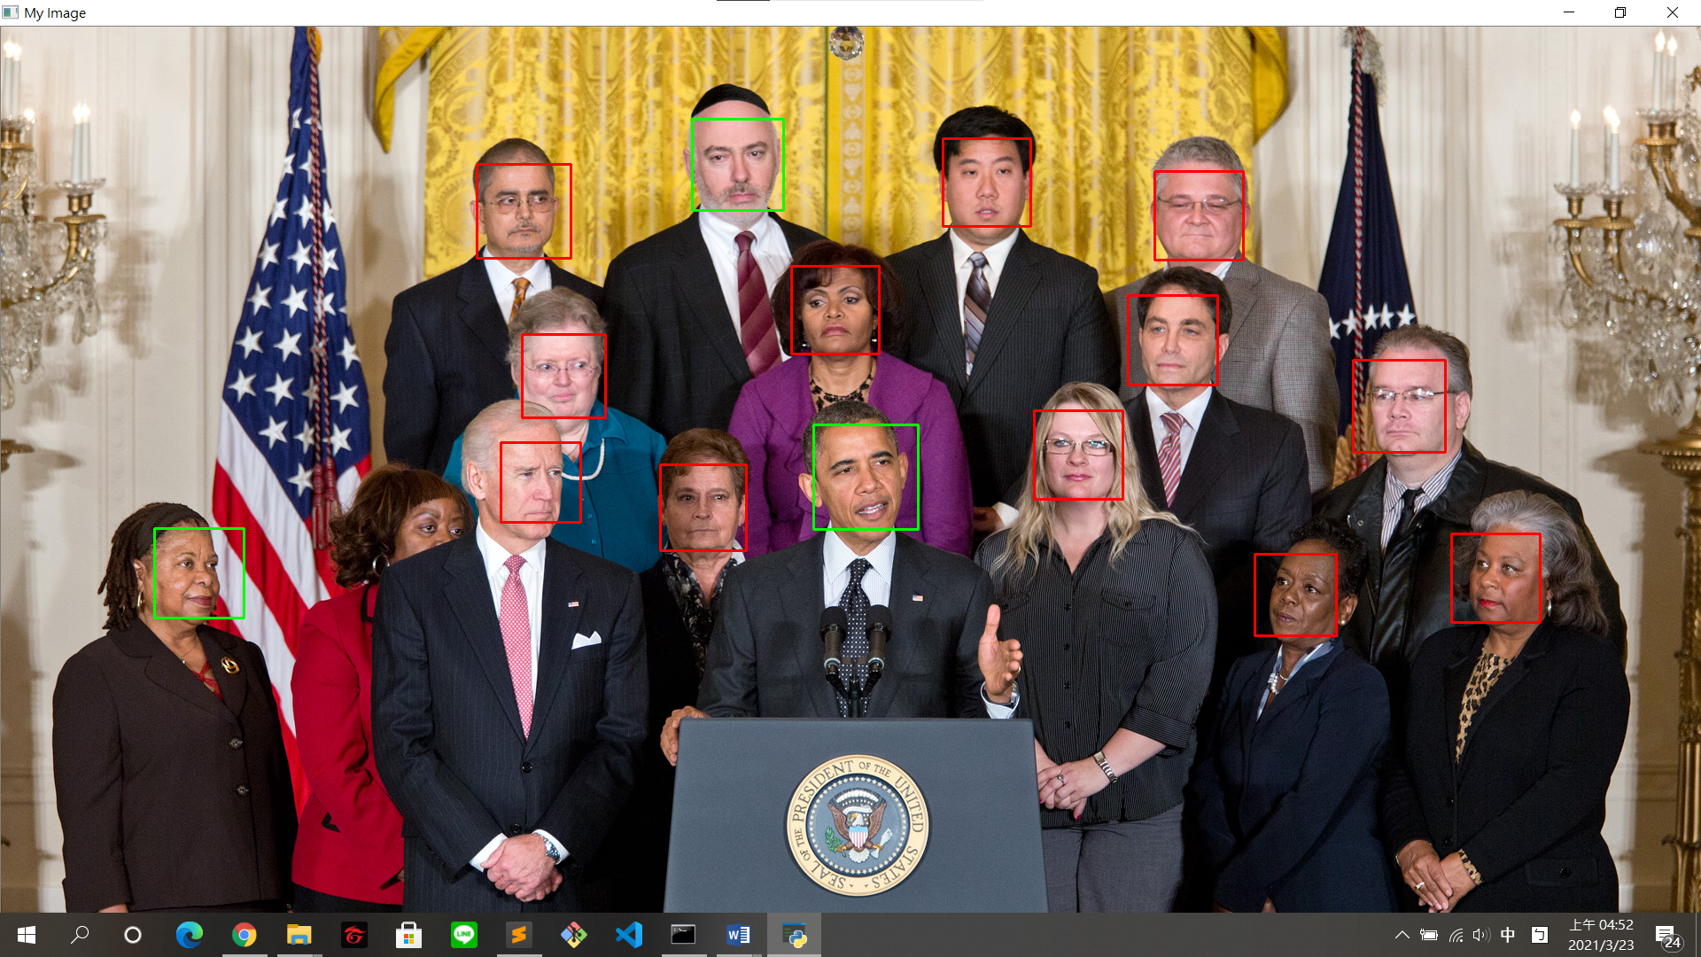

train

|  |  |  |  |  |  |  |  |  |  |  |
| --- | --- | --- | --- | --- | --- | --- | --- | --- | --- | --- |
| T | 1 | 2 | 3 | 4 | 5 | 6 | 7 | 8 | 9 | 10 |
| FPR(%) | 28 | 28 | 23 | 26 | 23 | 22 | 20 | 18 | 20 | 17 |
| FNR(%) | 10 | 10 | 1 | 2 | 0 | 0 | 0 | 0 | 0 | 0 |
| acc(%) | 81 | 81 | 88 | 86 | 88.5 | 89 | 90 | 91 | 90 | 91.5 |

test

|  |  |  |  |  |  |  |  |  |  |  |
| --- | --- | --- | --- | --- | --- | --- | --- | --- | --- | --- |
| T | 1 | 2 | 3 | 4 | 5 | 6 | 7 | 8 | 9 | 10 |
| FPR(%) | 49 | 49 | 48 | 49 | 49 | 50 | 52 | 47 | 48 | 45 |
| FNR(%) | 55 | 55 | 46 | 56 | 43 | 48 | 39 | 43 | 37 | 36 |
| acc(%) | 48 | 48 | 53 | 47.5 | 54 | 51 | 54.5 | 55 | 57.5 | 59.5 |

Accuracy increase with the growth of T, the phenomenon happens not only on training but also testing.

FNR decrease to 0 when T is bigger than 4. It means face won’t be classified as non-face in training.

The accuracy of training and that of testing differ a lot, they are almost 30% different. It implies that the classifier is sensitive to the dataset.

We should continue to train the model because training accuracy and testing accuracy are still tend to grow up.

Part 4: Detect face

Import module I need

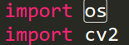

open the file and store the data into the relative lists

use “with open” and “readlines” traversal each lines

2 data 🡪 filename and # faces 4 data 🡪 x, y, w, h

Data procceeing: get each face in the image

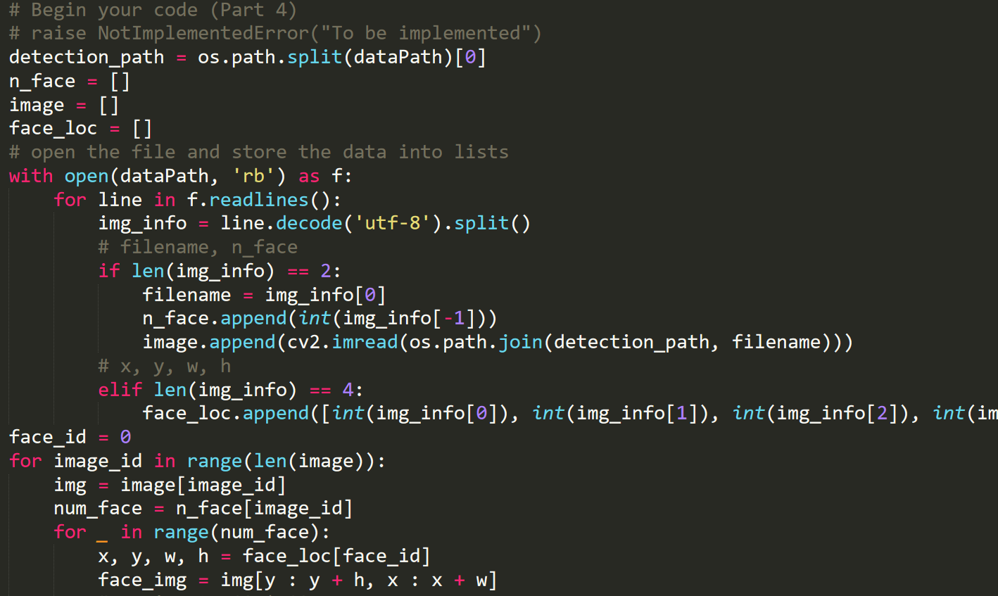

Get face location and risize the face image to 19 * 19

Convert face image to grayscale and than classify with the model

Predict with clf.classify

Draw the rectangle on the image and its color is according to the prediction is correct or not, and then show the result on the image.

Shrink the image which is too big too show

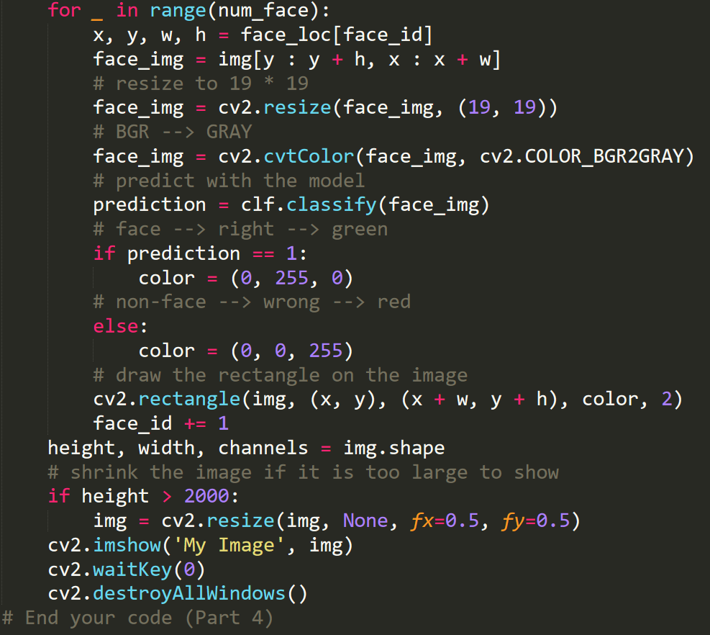

Example of the image with the predict result

(green: classify as face, red: classify as non-face)

T = 2





Part 5: Test classifier on your own images

My image path: data/detect_own

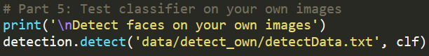

create a text file with the same format

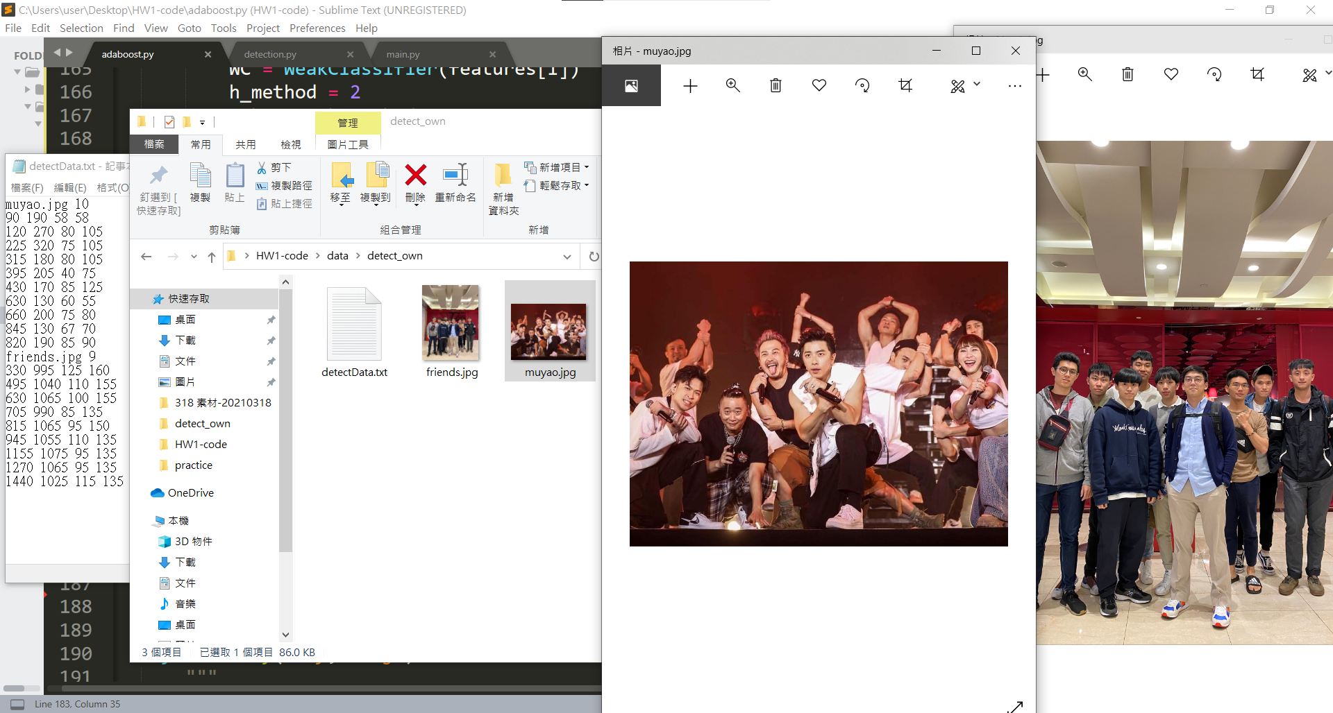

record the face location with photoshop, since PS can change the unit to pixels and enable you find the location in pixel conveniently.

handcraft labelling



Example of the image with the predict result

(green: classify as face, red: classify as non-face)

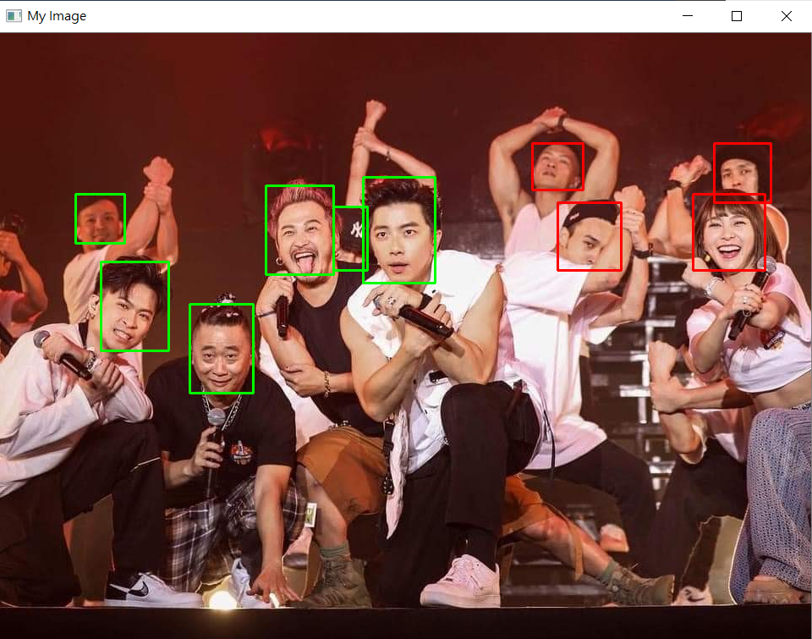

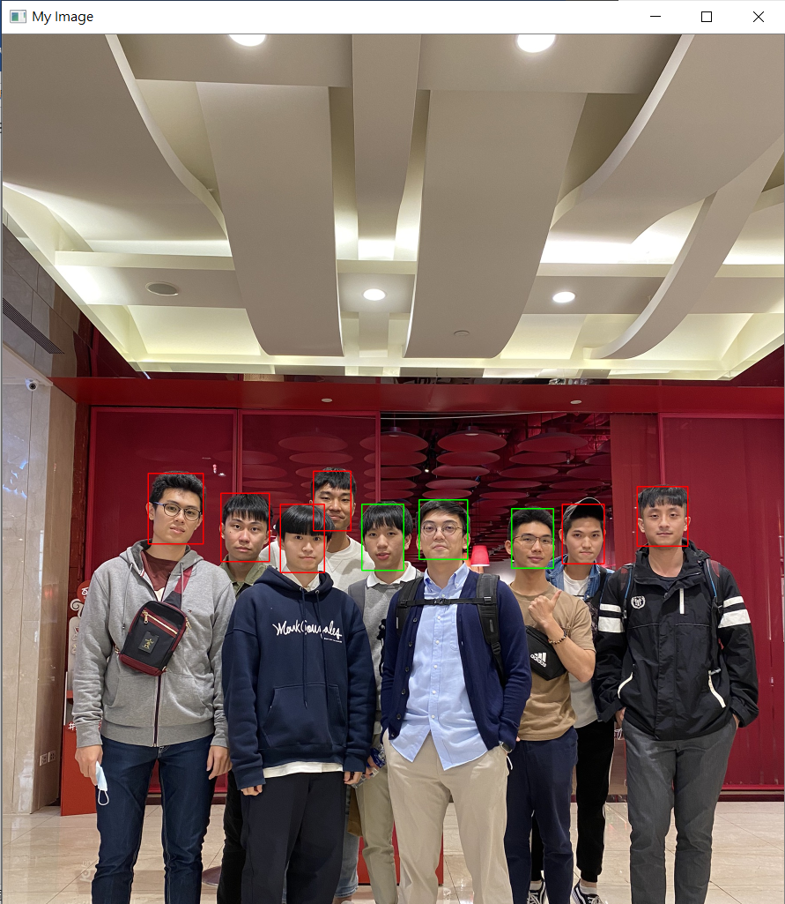

Part 6: Implement another classifier

Sigmoid + clip + binary cross entropy for binary classification

Sigmoid: 1 / (1 + e ^ x), other method for 0, 1 binary classification

[-inf, inf] 🡪 [0, 1]

1 - sigmoid since large number is predict to be 0, and negative number is predict to be 1

Clip h to avoid log(0)

binary cross entropy: - (1 / n) * sigma(y * log(f(x)) + (1 - y) * log(1 – f(x)))

other error method for binary classification

Knowing the best classifier, fix the best error to the adaboost need

Combinate L2-norm and BCE to calculate error and choose the best classifier with the comprehensive error

Fix the error that can be used in adaboost

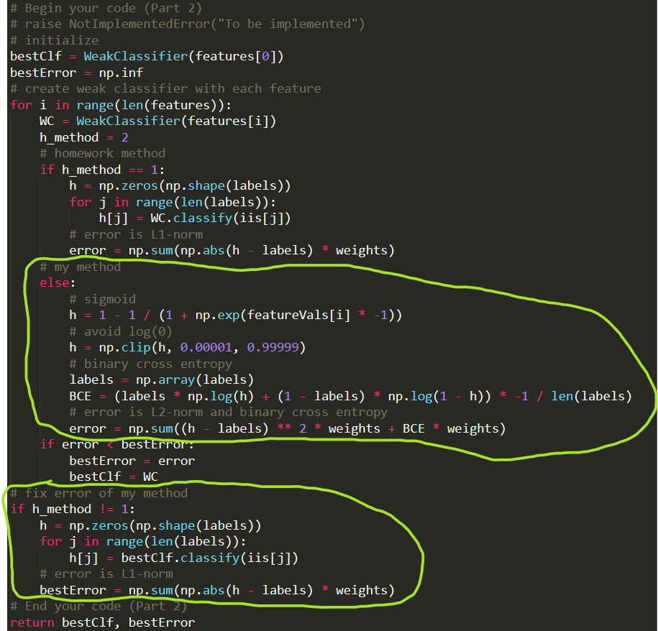

T = 1

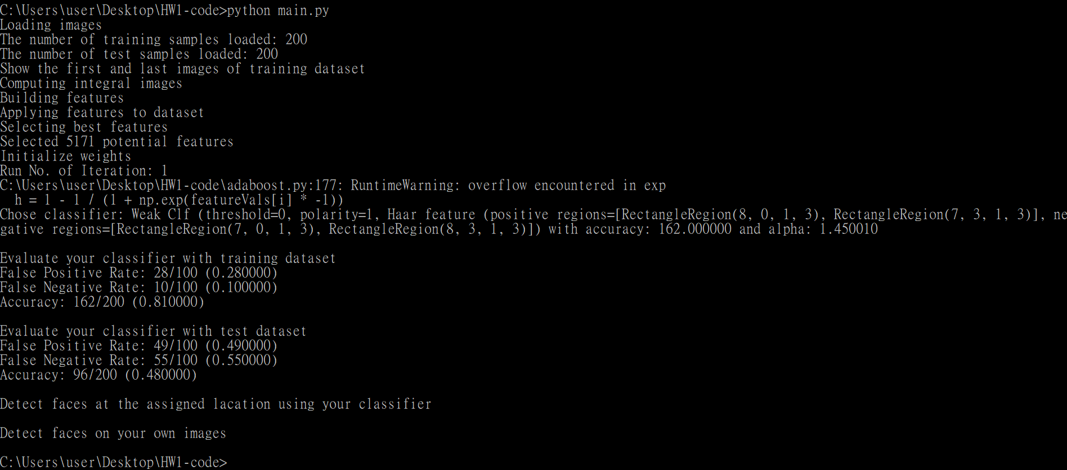

T = 2

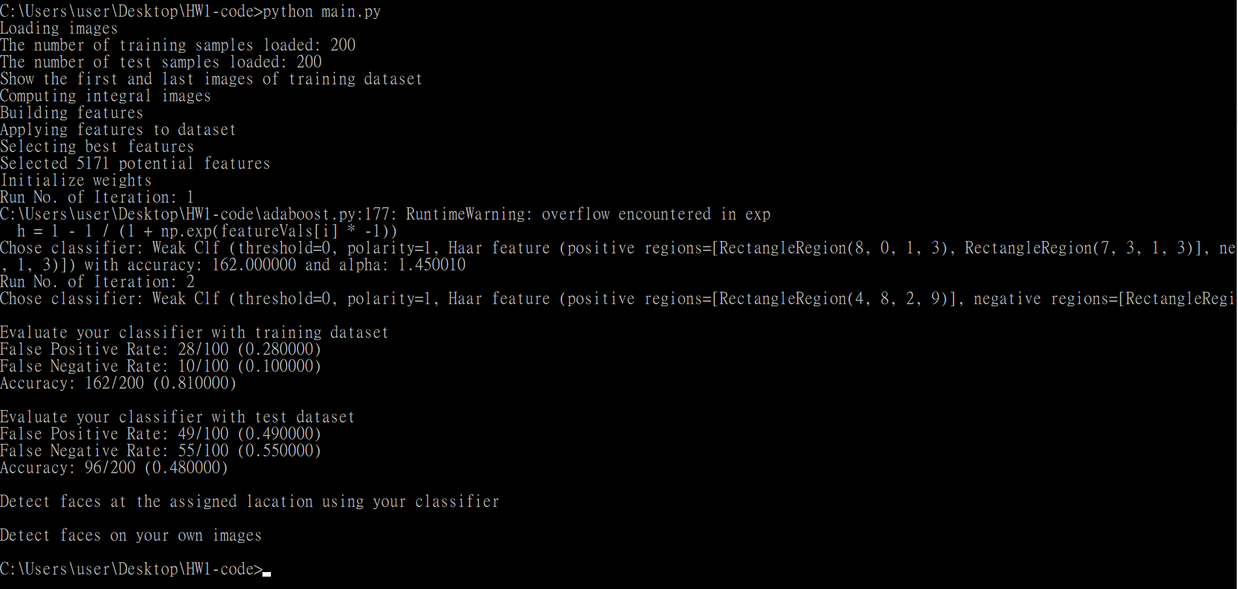

T = 3

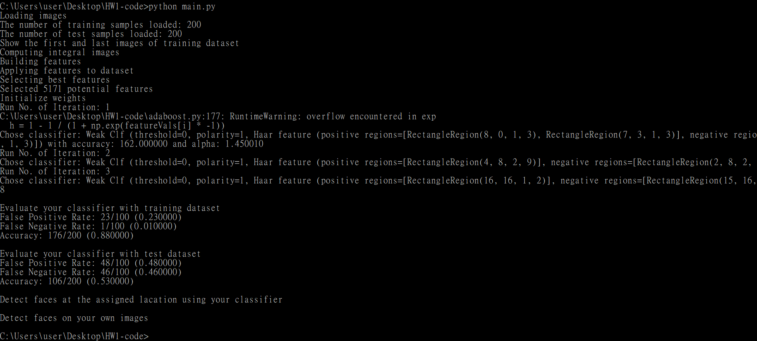

T = 4

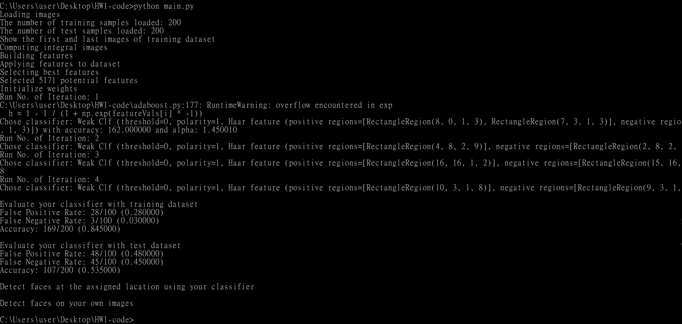

T = 5

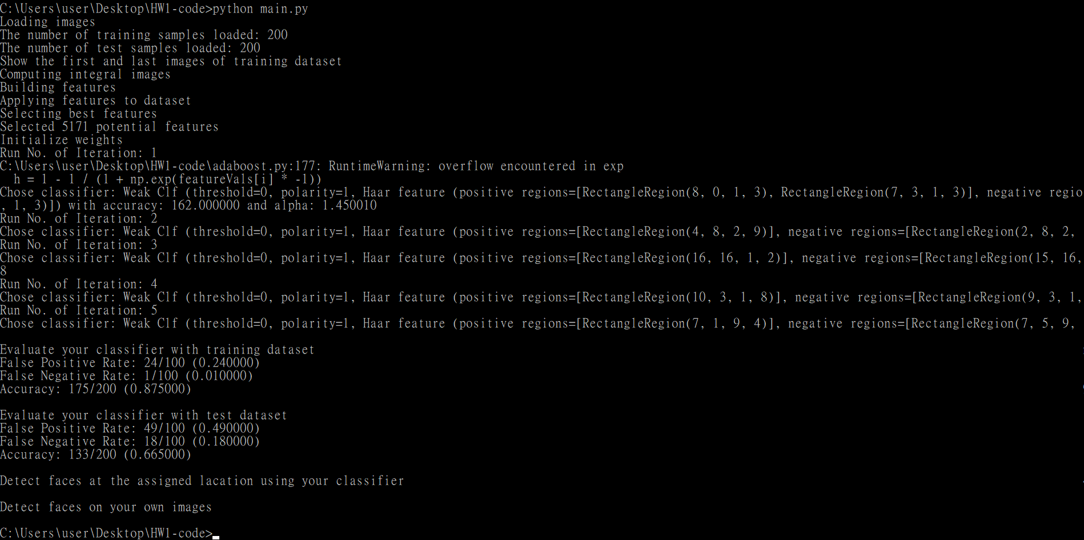

T = 6

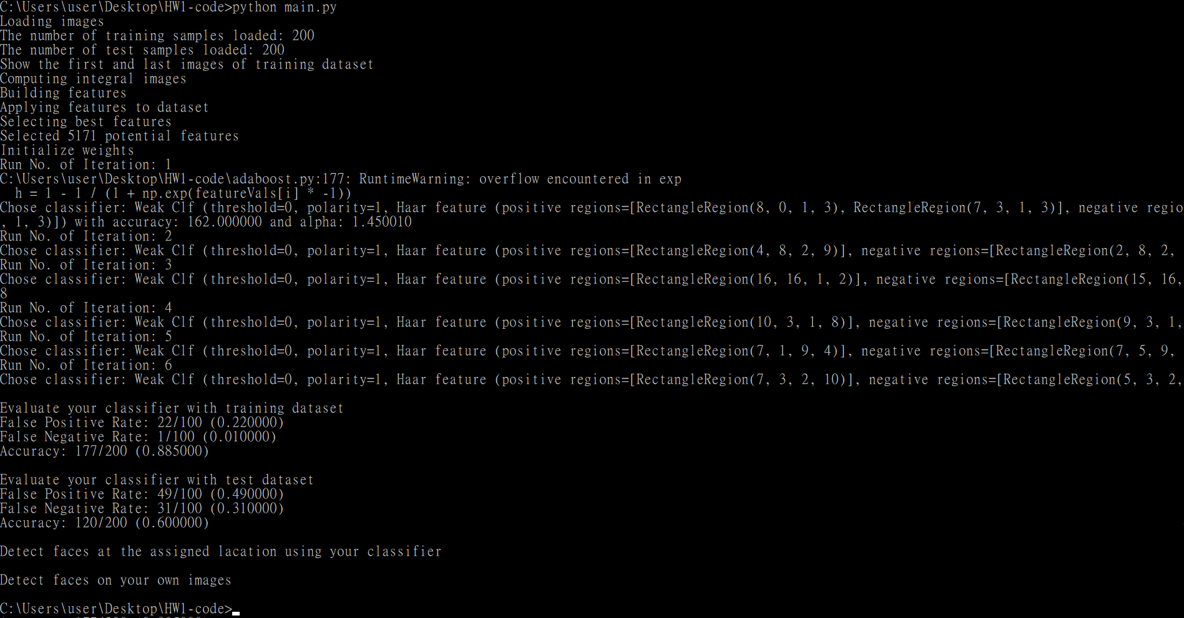

T = 7

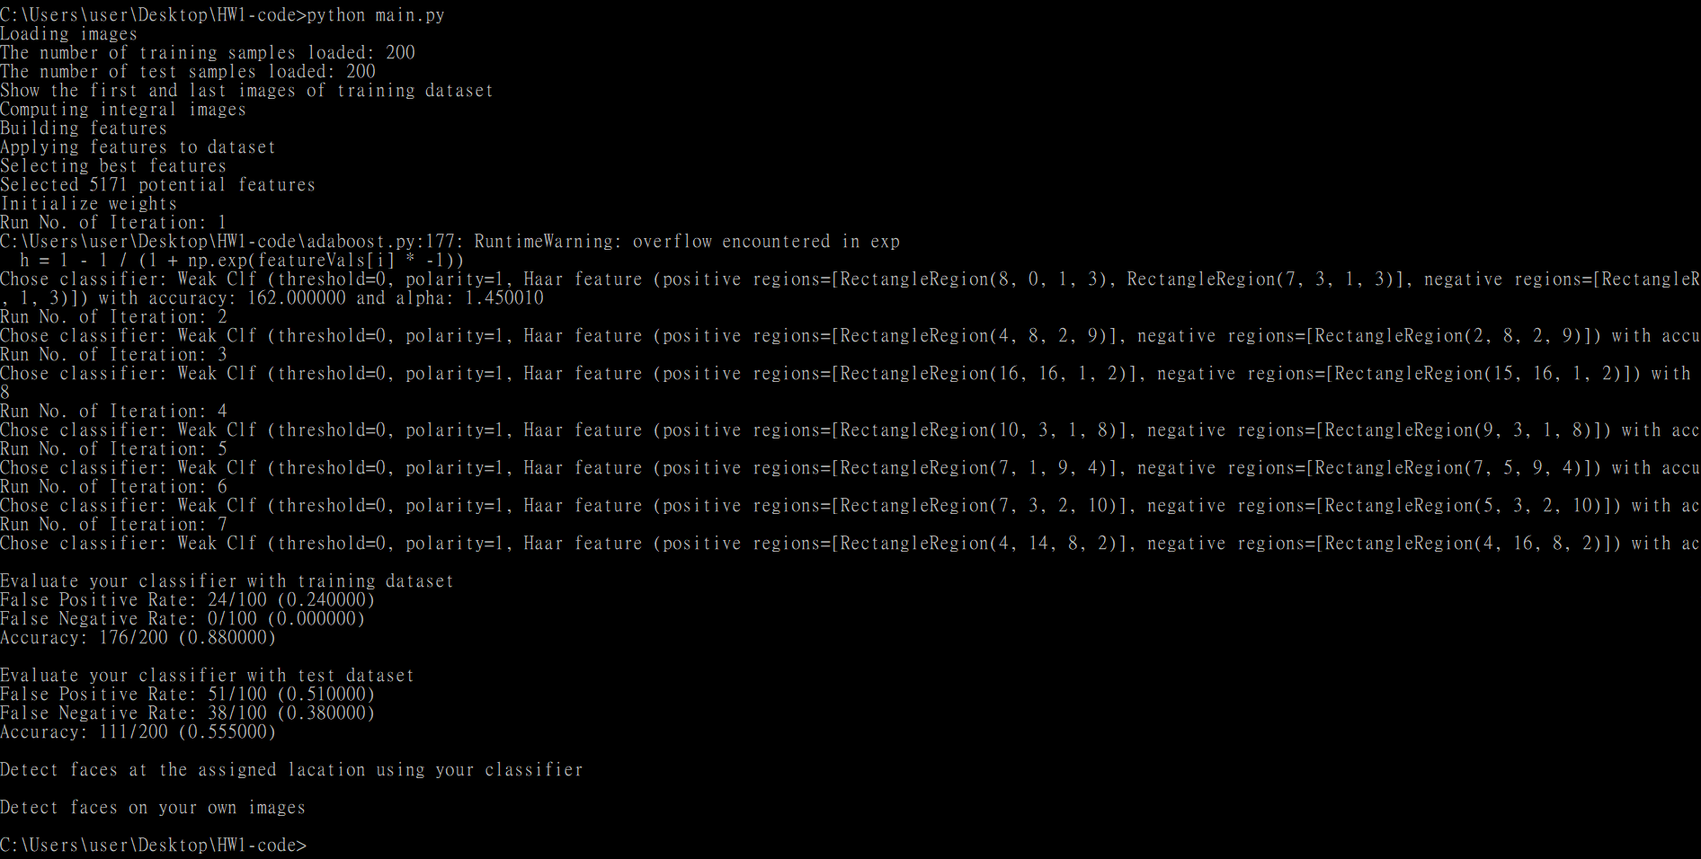

T = 8

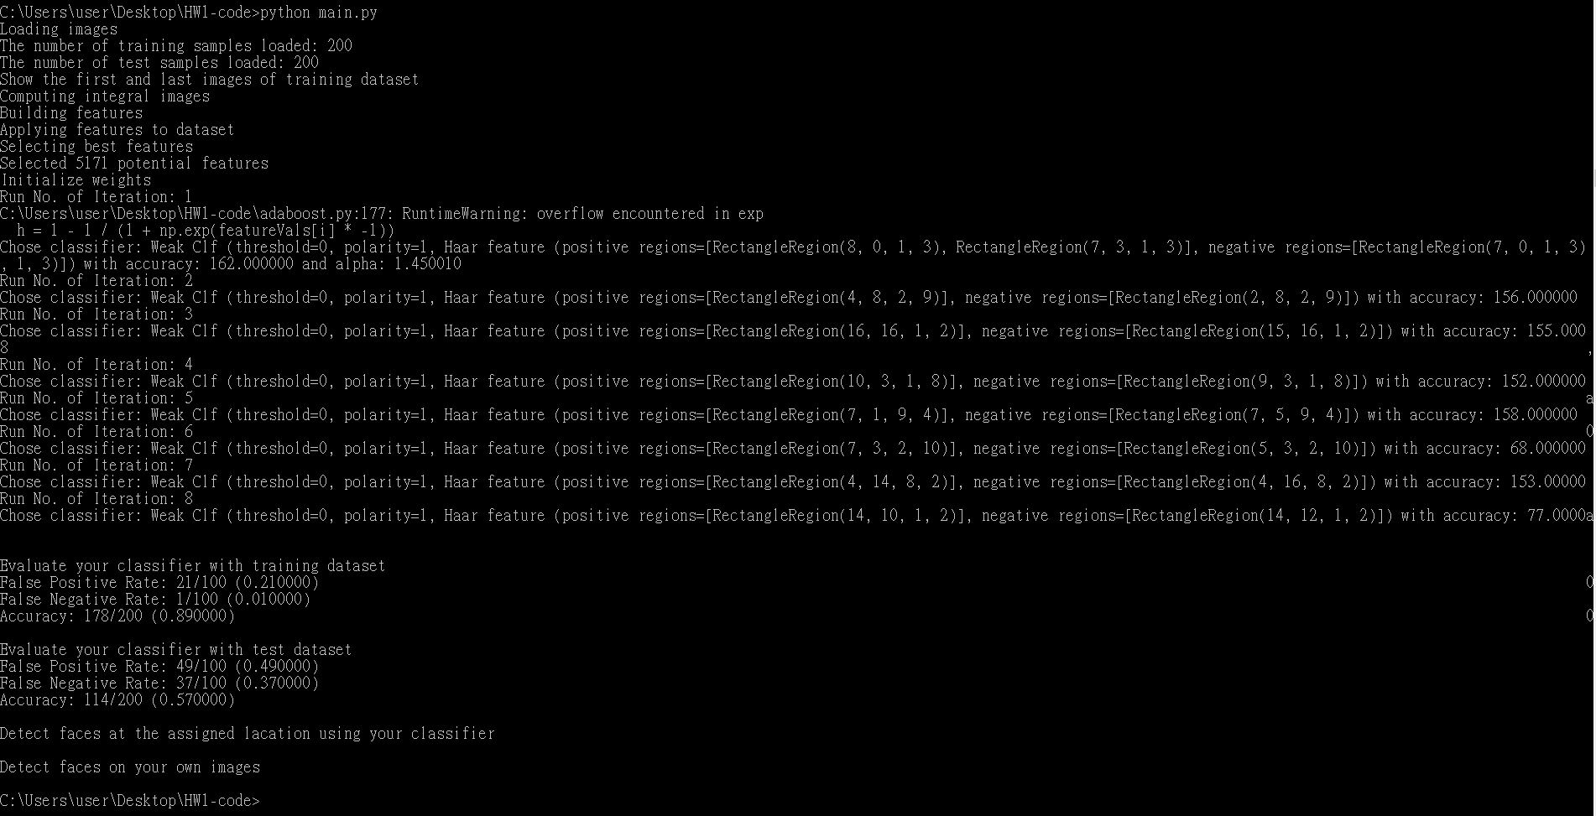

T = 9

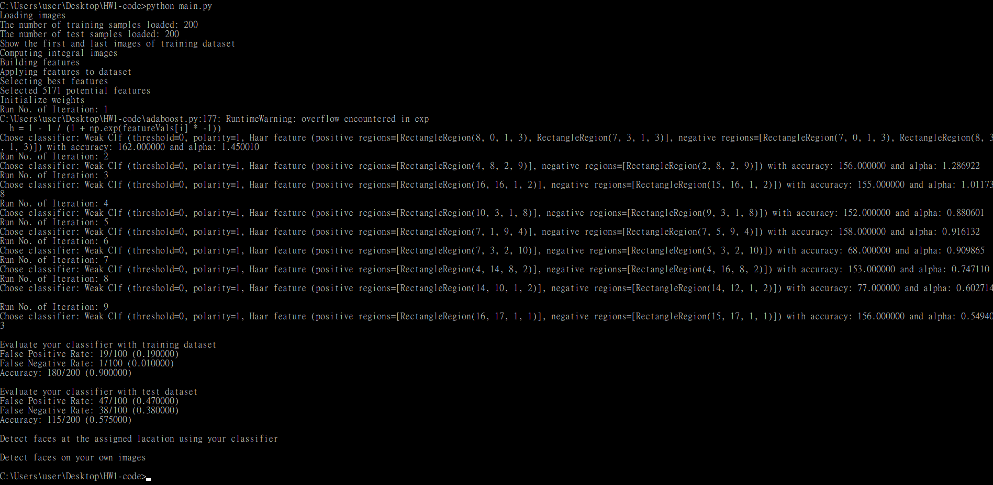

T = 10

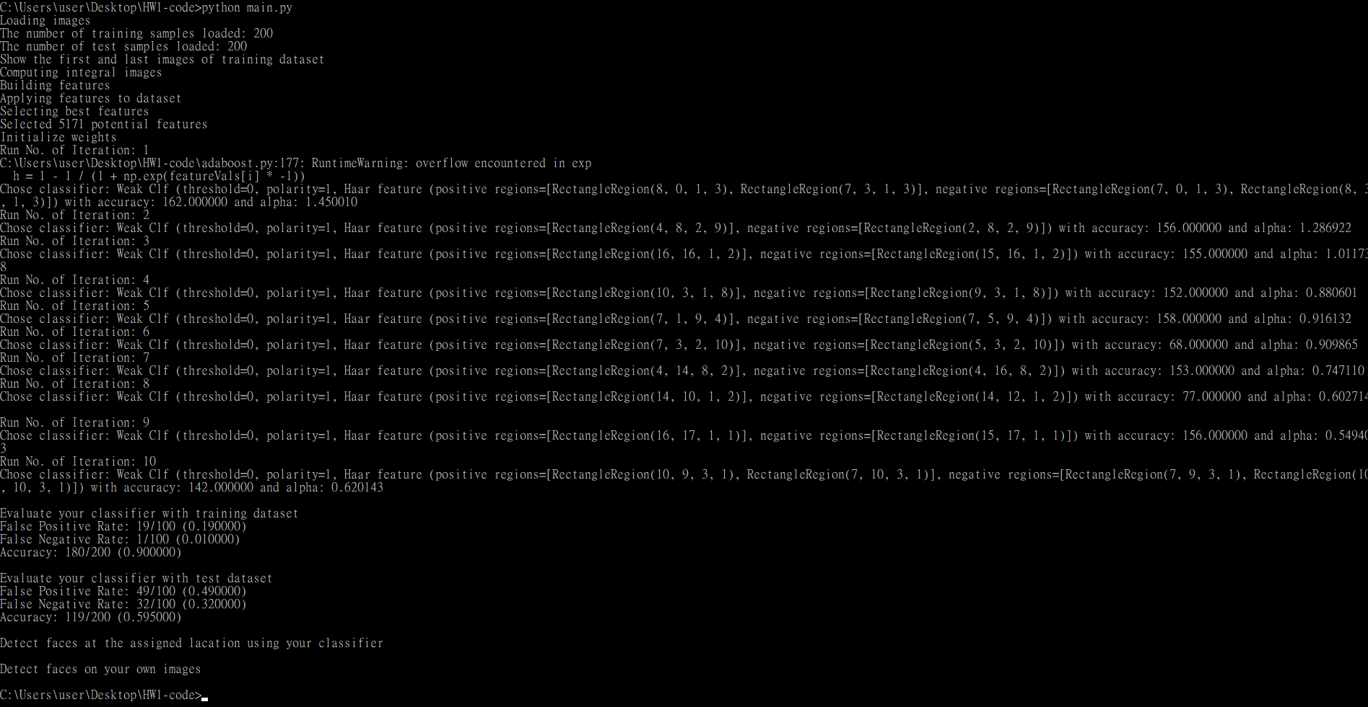

train

|  |  |  |  |  |  |  |  |  |  |  |
| --- | --- | --- | --- | --- | --- | --- | --- | --- | --- | --- |
| T | 1 | 2 | 3 | 4 | 5 | 6 | 7 | 8 | 9 | 10 |
| FPR(%) | 28 | 28 | 13 | 28 | 24 | 22 | 24 | 21 | 19 | 19 |
| FNR(%) | 10 | 10 | 1 | 3 | 1 | 1 | 0 | 1 | 1 | 1 |
| acc(%) | 81 | 81 | 88 | 84.5 | 87.5 | 88.5 | 88 | 89 | 90 | 90 |

test

|  |  |  |  |  |  |  |  |  |  |  |
| --- | --- | --- | --- | --- | --- | --- | --- | --- | --- | --- |
| T | 1 | 2 | 3 | 4 | 5 | 6 | 7 | 8 | 9 | 10 |
| FPR(%) | 49 | 49 | 48 | 48 | 49 | 49 | 51 | 49 | 47 | 49 |
| FNR(%) | 55 | 55 | 46 | 45 | 18 | 31 | 38 | 37 | 38 | 32 |
| acc(%) | 48 | 48 | 53 | 53.5 | 66.5 | 60 | 55.5 | 57 | 57.5 | 59.5 |

Accuracy increase with the growth of T, the phenomenon happens not only on training but also testing.

FNR decrease to almost 1 when T is bigger than 2. It means face won’t be classified as non-face in training.

The accuracy of training and that of testing differ a lot, they are almost 30% different. It implies that the classifier is sensitive to the dataset.

Overfitting after T = 5 since testing accuracy is decreasing but training accuracy is increasing when T > 5.

train (part2, 3)

|  |  |  |  |  |  |  |  |  |  |  |
| --- | --- | --- | --- | --- | --- | --- | --- | --- | --- | --- |
| T | 1 | 2 | 3 | 4 | 5 | 6 | 7 | 8 | 9 | 10 |
| FPR(%) | 28 | 28 | 23 | 26 | 23 | 22 | 20 | 18 | 20 | 17 |
| FNR(%) | 10 | 10 | 1 | 2 | 0 | 0 | 0 | 0 | 0 | 0 |
| acc(%) | 81 | 81 | 88 | 86 | 88.5 | 89 | 90 | 91 | 90 | 91.5 |

test (part2, 3)

|  |  |  |  |  |  |  |  |  |  |  |
| --- | --- | --- | --- | --- | --- | --- | --- | --- | --- | --- |
| T | 1 | 2 | 3 | 4 | 5 | 6 | 7 | 8 | 9 | 10 |
| FPR(%) | 49 | 49 | 48 | 49 | 49 | 50 | 52 | 47 | 48 | 45 |
| FNR(%) | 55 | 55 | 46 | 56 | 43 | 48 | 39 | 43 | 37 | 36 |
| acc(%) | 48 | 48 | 53 | 47.5 | 54 | 51 | 54.5 | 55 | 57.5 | 59.5 |

They doesn’t differ a lot in accuracy between Part 6 and Part 2, 3, but they are very different at T = 4, 5, 6.

Part 6 is overfitting, but Part 2, 3 isn’t

Accuracy increase with the growth of T in both part in training

Describe problems you meet and how you solve them.

How to get the face location in pixel?

Use PS to support locating face.

The concept of another classifier

Surf the Internet and find that Sigmoid and binary cross entropy are good for binary classification

Sigmoid isn’t good enough

Should apply 1 – Sigmoid instead of using sigmoid, since large number should be prediced to 0, and negative number should be prediced to 1.

Alpha < 0 in my former method

The error calculated by the best classifier which decided by the error with binary cross entropy is more than 0.5.

The error which choose the best classifier should consider not only binary cross entropy but also distence like L2-norm.